**COMP 642 Assignment --- MODULE 9**

1. Given a one channel gray scale image of size 6 * 6 shown below, if a 5 2 * 2 filters are applied with stride size equal to 2 and no padding to the image, what will be the size of the result? How many trainable parameters will there be in this layer? (each filter has its own bias).

|  |  |  |  |  |  |
| --- | --- | --- | --- | --- | --- |
| 1 | 1 | 2 | 3 | 4 | 2 |
| 2 | 5 | 9 | 7 | 6 | 5 |
| 1 | 2 | 0 | 1 | 5 | 4 |
| 1 | 2 | 2 | 1 | 7 | 0 |
| 6 | 4 | 0 | 1 | 5 | 2 |
| 4 | 3 | 3 | 2 | 5 | 1 |

Image

1. If there is padding of one pixel around the image above, what will be the result for the first question?
2. Apply the following filters with stride equal to 1 to the image above. What kind of possible feature in the image do you think can be captured by these filters?

|  |  |  |
| --- | --- | --- |
| -1 | -1 | -1 |
| 1 | 1 | 1 |
| -1 | -1 | -1 |



|  |  |  |
| --- | --- | --- |
| -1 | 1 | -1 |
| -1 | 1 | -1 |
| -1 | 1 | -1 |



|  |  |  |
| --- | --- | --- |
| 1 | -1 | -1 |
| -1 | 1 | -1 |
| -1 | -1 | 1 |

1. What will be the result if applying a 3 * 3 max pooling filter to the image?
2. Below is a diagram of a small convolutional neural network that converts a 13x13 image into 4 output values.

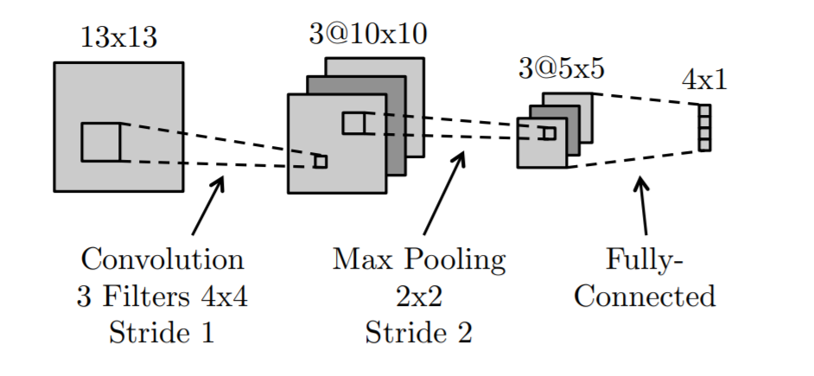

The network has the following layers/operations from input to output: convolution with 3 filters, max pooling, ReLu, and finally a fully-connected layer. There are no bias/offset parameters

1. How many weights in the convolutional layer do we need to learn?
2. How many ReLu operations are performed on the forward pass?
3. How many weights do we need to learn for the entire network?
4. Would a fully-connected neural network with the same size layers as the above network (13x13 → 3x10x10 → 3x5x5 → 4x1) be able to represent any classifier that the above convolutional network can represent? Explain.
5. What is the disadvantage of a fully-connected neural network compared to a convolutional neural network with the same size layers?
6. Execute hw_9.ipynb. Apply the sample code to a data set of your choosing and document the results in this file and show the results in the Jupyter notebook.